# C5- S6 – PRACTICE

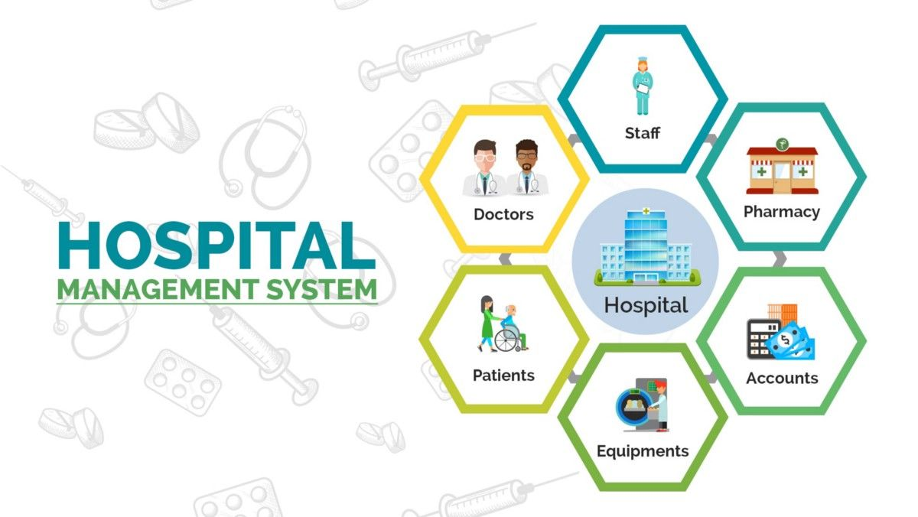

We want to create a hospital management system:

* To manage the staff (doctor, nurses…)
* To manage the patients
* To manage the room and bed allocated to patient
* To manage patient appointments and doctors meetings

**A) Understand**

1. Read existing code
2. Understand existing UML diagram (START UML)
3. Answer following questions:

Q1 - Write the code to create a new hospital with a name and address:

Q2 – With this new hospital, write the code to add 2 new rooms (ROOM1 and ROOM2) and 2 beds on each rooms

Q3 – With this new hospital, write the code to add 2 patients (RADY and JEANNE), and assign them to each rooms created

Q4 – With this new hospital, write the code to add a doctor (Doctor HIM) and a nurse (nurse RONAN)

Q5 – With this new hospital, write to create a doctor appointment:

* Start : APRIL 14 2022 at 8am
* End: APRIL 14 2022 at 10am
* Doctor = HIM
* Patient : JEANNE

**B) Find a free room**

Q6 - In the **RoomManager** class, complete the code to find a room available (with a free bed)

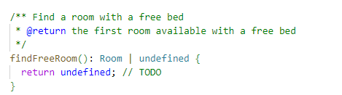

Q7 – Test this method:

* Make sure the hospital is full (put a patient on each bed)
* Check your method returns **undefined**
* Remove a patient from a room  *(you need to add a new method)*
* Check your method returns this room, since now the room has 1 free bed

**C) Find a doctor**

Q8 - In the **HumanManager** class, complete the code to find a doctor skilled with the given disease

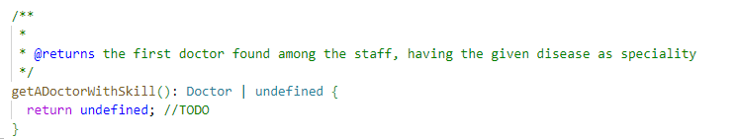

Q9 – Test this method:

* Create a doctor with a disease, make sure it’s the only doctor with this disease
* Check your method can find this doctor

**D) Find a free calendar slot**

Q10 - In the **CalendarManager** class, complete the code to find all appointment for the given doctor:

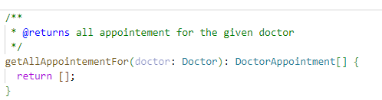

Q11 - In the **CalendarManager** class, complete the code to check if a doctor is free at a given date (you will need to use the previous method)

